MD2201: Data Science

Name of the student: Nisha Modani Roll No. 66

Div: CS-B Batch: B3

Date of performance:

Experiment No.3

Title: Hypothesis Testing
Aim: i. To perform hypothesis testing for single sided tail.
ii. To perform hypothesis testing for Two-sided tail.

Software used: Programming language R.

Code Statement:
- Suppose the manufacturer claims that the mean lifetime of a ball bearing is 10000hours. The auditing team stated that the mean lifetime is less than what is claimed. On the basis of a randomly chosen sample of 50 ball bearings as given in the dataset, at 0.05 significance level, can we reject the claim of the manufacturer? What will be your interpretation if the significance level is made as 0.01? Consider the data set titled “Hypothesis_csv1.csv”.

- The nutrition label on a bag of potato chips says that a one ounce (28 gram) serving of potato chips has 130 calories and contains ten grams of fat, with three grams of saturated fat. A random sample of 35 bags yielded a sample mean of 134 calories with a standard deviation of 17 calories. Is there evidence that the nutrition label does not provide an accurate measure of calories in the bags of potato chips? We have verified the independence, sample size,and skew conditions are satisfied

Code: (Write code for above statements here)
Code 1:
getwd()
setwd("C:/Users/HP/Desktop/Data science/Data sets")
d<-read.csv("hypothesis testing.csv",header=T)

m<-mean(d$Life_Hrs)
cat("mean of data: ",m)

sd<-sd(d$Life_Hrs)
cat("\nstandard deviation: ",sd)

se<-sd/sqrt(50)
cat("\nstandard error: ",se)
p<-pnorm(m,10000,se)
cat("\n",p)
if(p<0.05){
cat("\nmanufacturer claim to be rejected for alpha=0.05")
}else{
cat("\nmanufacturer claim holds good for alpha=0.05")
}

if(p<0.01){
cat("\nmanufacturer claim to be rejected for alpha=0.01")
}else{
cat("\nmanufacturer claim holds good for alpha=0.01")
}

Code 2:
m<-134
cat("mean: ",m)
sd<-17
cat("\nstandard deviation: ",sd)
se<-sd/sqrt(35)
cat("\nstandard error: ",se)
p<-2*(pnorm(m,130,se,lower.tail = F))
cat("\npvalue: ",p)
if(p<0.05){
cat("\nthere is evidence that the nutrition label does not provide an accurate
measure of calories in the bags of potato chips for alpha=0.05")
}else{
cat("\nnutrition label provides accurate measures for alpha=0.05")
}
if(p<0.01){
cat("\nthere is evidence that the nutrition label does not provide an accurate
measure of calories in the bags of potato chips for alpha=0.01")
}else{
cat("\nnutrition label provides accurate measures for alpha=0.01")
}

Results: Display the output obtained on R console for all the cases.

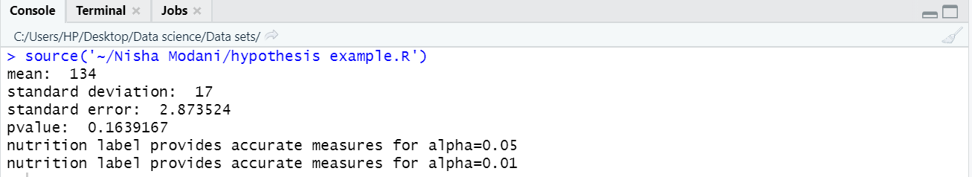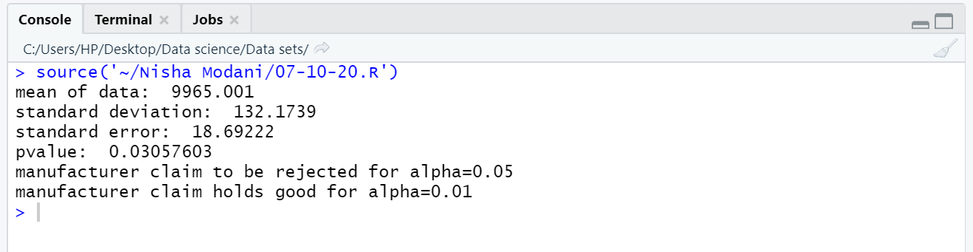

Conclusion: (Write the conclusion in your words).

From this experiment I have learned to use r command for hypothesis testing and following are the conclusions:

First need to find p value from given data like mean standard deviation null hypothesis and alternate hypothesis

Whenever p-value is greater than significance level we accept null hypothesis which means we don’t have enough evidence against null hypothesis

Whenever p-value is less than significance level we reject null hypothesis which means we have enough evidence against null hypothesis

